
Mawlana Bhashani Science and Technology University
Department of Information and Communication Technology
Course title : Database Management System Lab
Course code : ICT-2110
No | Lab Title | Page | Signature | Remarks
01 | Installation of MySQL
02 | Data types in MySQL.
03 | Understand and implement basic database commands
04 | Basic query of MySQL.
05 | Different Types of Joining Operation.
06 | Implementation of database triggers.

Submitted By | Submitted To
Name: Monirojjaman Ayoive  ID: IT-23013  2nd Year, 1st Semester  Session: 2022-2023  Dept. of ICT, MBSTU | Dr. Md. Abir Hossain  Associate Professor  DEPARTMENT OF INFORMATION AND COMMUNICATION TECHNOLOGY  MAWLANA BHASHANI SCIENCE AND TECHNOLOGY UNIVERSITY
Date of Performance:23-11-2024 Date of Submission:30-11-24
Objective:
To understand and implement basic database commands such as creating databases, tables, inserting data, renaming tables, adding/deleting columns, modifying column types, and using others commands.

Required Instruments:
- Computer with RAM at-least 4GB
- MySQL 9.1.0 Command Line Client
- Internet Connection

1. Input Password to start working on MySQL
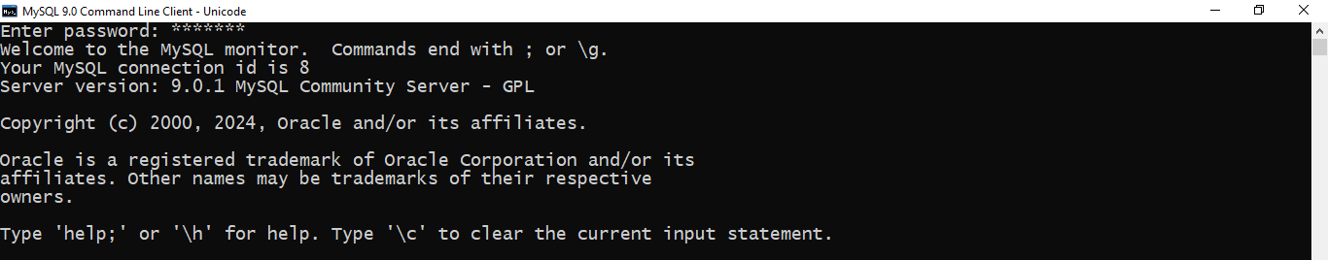

MySQL Command Line Client will allow user working after giving the password user set during MySQL installation. So, I gave my password and become started working on MySQL command Line Client.

2. Creating Database


Command: CREATE DATABASE Lab3;
This command creates a new database named Lab3.After creating a new database, we can work with it. We will use this database for further operations.

3. Using Database

Command: Use Lab3; The USE Lab3 command in MySQL is used to select a specific database to work with.

4. Viewing database
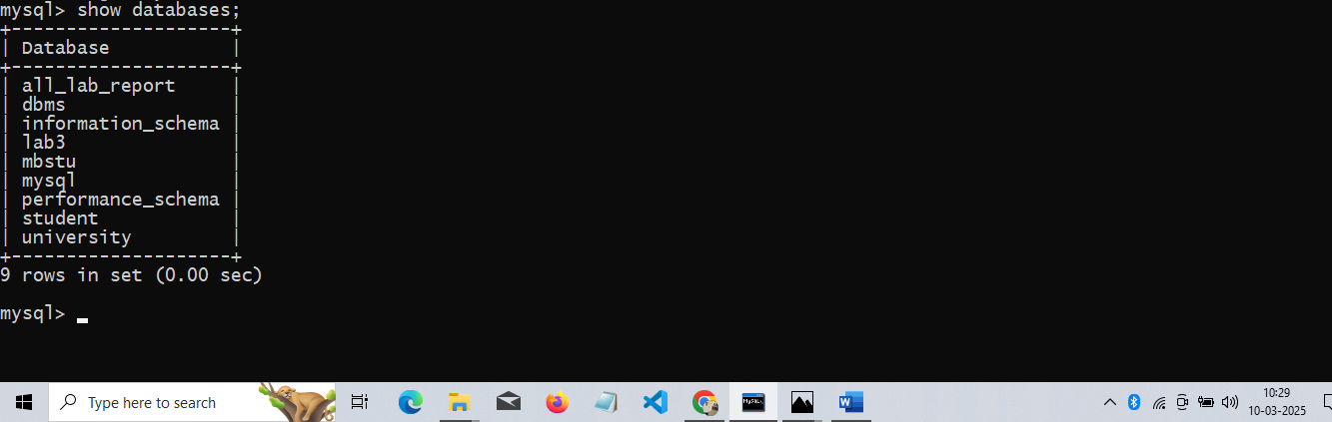

Command: show database;
The SHOW DATABASES; command in MySQL is used to display a list of all the databases available on the MySQL server that the user has permission to access.

5.Creating new Table
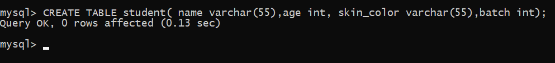

Command: CREATE TABLE student( name varchar(55),age int, skin_color varchar(55),batch int);

The CREATE TABLE command in SQL is used to define and create a new table within a database, specifying its name, columns, data types, and constraints such as PRIMARY KEY, NOT NULL, or UNIQUE to ensure data integrity.

6. Viewing tables in a database
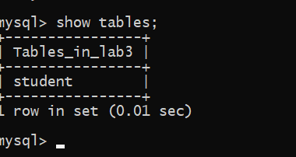

Command: show tables;
The SHOW TABLES command in SQL is used to display a list of all the tables present in the currently selected database. It helps users confirm the existence of tables, check their names, and verify table creation. To use it, ensure you have selected a database with USE database_name; beforehand.

7.Inserting into a table
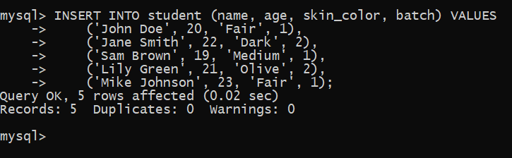

Command: INSERT INTO student (name, age, skin_color, batch) VALUES

('John Doe', 20, 'Fair', 1),

('Jane Smith', 22, 'Dark', 2),

('Sam Brown', 19, 'Medium', 1),

('Lily Green', 21, 'Olive', 2),

('Mike Johnson', 23, 'Fair', 1);
The INSERT INTO command in SQL is used to add new rows of data into a table. You can insert data into all columns or specific ones by specifying
column names. For example, INSERT INTO
student(name,age,skin_color,batch) VALUES ("John Doe",20,"Fair",1); adds a new row to the Students table. It ensures data is added according to the table's defined structure and constraints.

8.Viewing a table
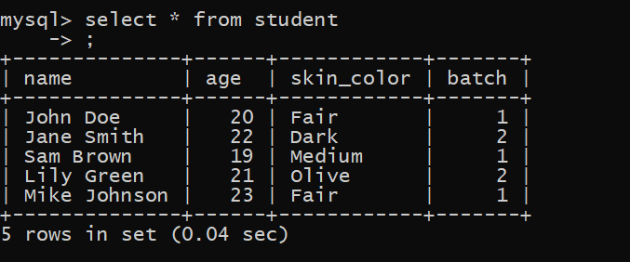

Command: SELECT * FROM student;
The SELECT * FROM Students; command in SQL retrieves all rows and columns from the Students table. The asterisk (*) is a wildcard that means "all columns," so this query will return every piece of data stored in the table.

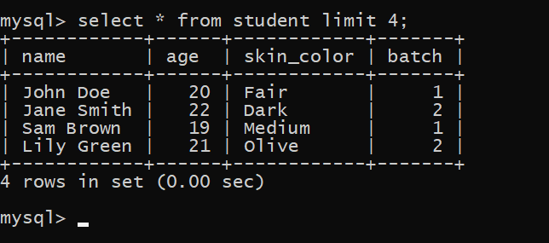

Command: SELECT * FROM student limit 4;

The LIMIT clause in SQL is used to specify the number of records to return from a query. For example, SELECT * FROM Students LIMIT 4; will retrieve only the first 4 rows from the Students table.

9.Rename a table
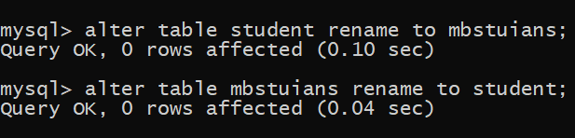

Command: alter table student rename to mbstuians;
The RENAME TABLE command in SQL is used to change the name of an existing table. For example, alter table student rename to mbstuians; renames the Students table to ictians This command helps when reorganizing or renaming tables for better clarity or to fit new naming conventions.

10. Adding a new column to a table
The ALTER TABLE command with ADD COLUMN is used to add a new column to an existing table. For example, ALTER TABLE Students ADD eamil VARCHAR(100); adds a new Email column to the Students table, with a data type of VARCHAR and a maximum length of 100 characters. This allows you to expand the table's structure by including additional data.
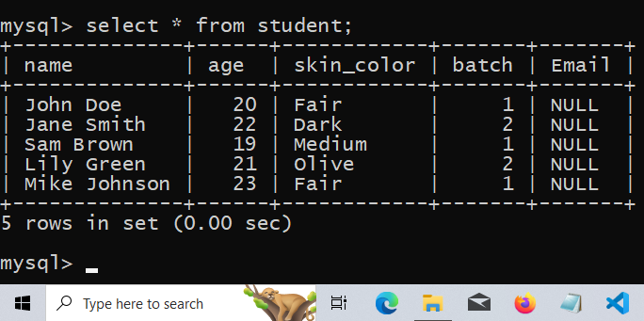
Command: ALTER TABLE Students ADD Email VARCHAR(100);

11.Modify a column


Command: ALTER TABLE Student modify eamil VARCHAR(1000);
The MODIFY command in SQL, used within ALTER TABLE, allows you to change the definition of an existing column, such as its data type, size, or constraints. For example, to change the data type of the Email column in the Students table from VARCHAR(50) to VARCHAR(100)

12.Drop a column
The ALTER TABLE command with DROP COLUMN is used to remove a column from an existing table. For example, to remove the eamil column from the Students table,

Command:alter table student drop column eamil;
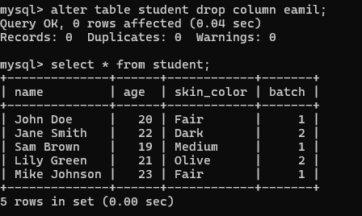

13. Update a record
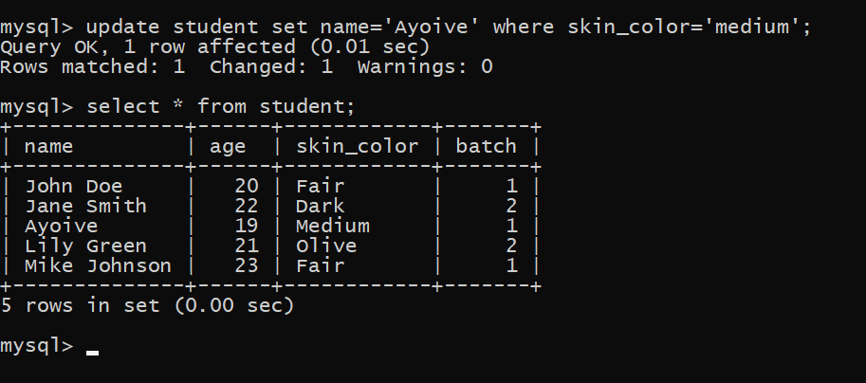

Command: update student set name='Ayoive' where skin_color='medium';
The UPDATE command in SQL is used to modify existing records in a table. You specify the table, set the new values for one or more columns, and use the WHERE clause to filter which rows should be updated.

14. Retrieving specific column
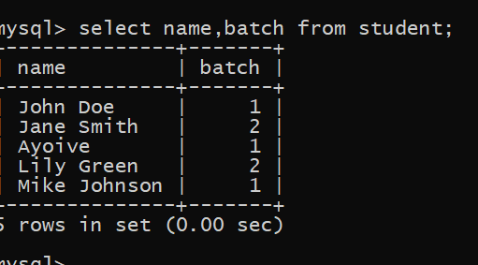

Command: select name, batch from student;
This retrieves only the Name and Age columns for all rows in the Students table.

15. Drop Table
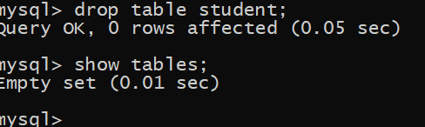

Command: drop table student;
The DROP TABLE command in SQL is used to permanently delete a table and all its data from the database.
Conclusion:
SQL provides essential commands like CREATE TABLE, INSERT INTO, SELECT, UPDATE, and DROP to efficiently manage and manipulate data in a database. These commands allow for the creation of structured data storage, insertion and retrieval of data, modification of existing records, and removal of unwanted tables or data.

